Ex:No: 12

Date:

**Simple Programming using REPEAT, WHILE**

**Aim:**

To learn how to use various MySQL loop statements including while, repeat to run a block of code repeatedly based on a condition.

**WHILE loop Syntax:**

**WHILE** expression

**DO** statements

**END WHILE;**

**Procedure:**

1. The WHILE loop checks the expression at the beginning of each iteration.
2. If the expression valuates to TRUE, MySQL will execute statements between WHILE and END WHILE until the expression evaluates to FALSE.
3. The WHILE loop is called pretest loop because it checks the expression before the statements execute.

The following flowchart illustrates the WHILE loop statement:

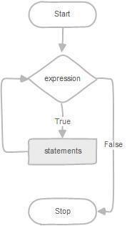

**REPEAT loop Syntax:**

**REPEAT** statements

**UNTIL** expression

**END REPEAT;**

**Procedure:**

1. First, MySQL executes the statements, and then it evaluates the expression.
2. If the expression evaluates to FALSE, MySQL executes the statements repeatedly until the expression evaluates to TRUE.
3. Because the REPEAT loop statement checks the expression after the execution of statements, the REPEAT loop statement is also known as the post-test loop.

The following flowchart illustrates the REPEAT loop statement:

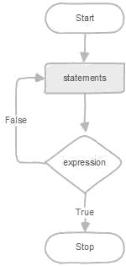

**Program-1:**

Write a function that uses WHILE statement to build a string repeatedly until the value of the variable becomes x greater than 5. Then, we display the final string using a SELECT statement.

**Program-2:**

Write a function that uses REPEAT statement which would repeat the loop until income is greater than or equal to 4000, at which point the REPEAT loop would be terminated.

**Program-1:**

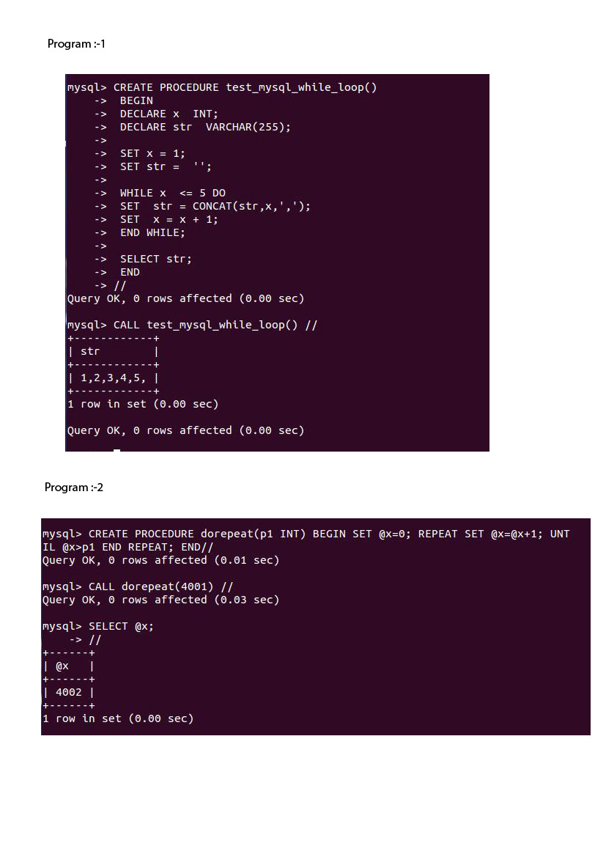

**Program-2:**



**RESULT:** Thus the Simple programming exercise using (REPEAT, WHILE ) executed successfully